DIMENSIONS

DIMENSIONS A B C D E F G H I J K L M N O .

DE-300S 2'-11" 2'-10" 5'-8" 11'-6" 24'-10 1/2" 14'-2 5/8" 28'-5 1/4" 4'-1 1/8" 1'-2 7/8" 0'-5 1/4" 5'-4" 1'-2 7/8" 1'-4 11/16" 2'-10 1/2" 6'-8 11/16"
DE-400 5'-5" 2'-10" 5'-8" 14'-0" 28'-2 1/2" 15'-10 5/8" 31'-9 1/4" 4'-2 1/2" 1'-3" 2'-0" 5'-4" 1'-3" 1'-4 1/2" 2'-9 1/2" 6'- 10"
DE-600 6'-8" 3'-2" 6'-4" 15'-11" 30'-3 1/4" 17'-0 1/8" 34'-0 1/4" 4'-4 1/2" 0'-7 1/16" 2'-3 7/8" 5'-4" 1'-3 1/16" 1'-6 1/2" 2'-9 7/8" 7'-1 1/16"
DE-650 6'-8" 3'-2" 6'-4" 15'-11" 30'-3 1/4" 17'-0 1/8" 34'-0 1/4" 4'-4 1/2" 0'-7 1/16" 2'-3 7/8" 5'-4" 1'-3 1/16" 1'-6 1/2" 2'-9 7/8" 7'-1 1/16"

DIMENSIONS P R S T U V W X Y Z AA BB CC DD EE .

DE-300S 8'-9 7/8" 12'-0" 1'-9 3/8" 7'-7 3/16" 3'-0 5/8" 2'-9" 2'-6" 5'-1 3/16" 14'-8 3/8" 4'-8 1/2" 7'-11" 3'-2 1/2" 9'-5" 0'- 4 3/4" 10'-7 3/16"
DE-400 8'-9 7/8" 12'-0" 1'-9 3/8" 7'-7 3/16" 3'-0 5/8" 2'-9" 2'-6" 5'-1 3/16" 14'-9 3/4" 4'-8 1/2" 7'-8" 2'-10" 9-'8" 0'- 4 3/4" 10'-7 3/16"
DE-600 8'-9 7/8" 12'-8 1/4" 1'-10 1/2" 7'-7 3/16" 3'-0 5/8" 2'-9" 2'-6" 5'-1 3/16" 14'-10 11/16" 4'-8 1/2" 7'-6" 3'-7" 9'-10" 0'- 4 1/16" 10'-7 3/16"
DE-650 8'-9 7/8" 12'-8 1/4" 1'-10 1/2" 7'-7 3/16" 3'-0 5/8" 2'-9" 2'-6" 5'-1 3/16" 14'-10 11/16" 4'-8 1/2" 7'-6" 3'-7" 9'-10" 0'- 4 1/16" 10'-7 3/16"
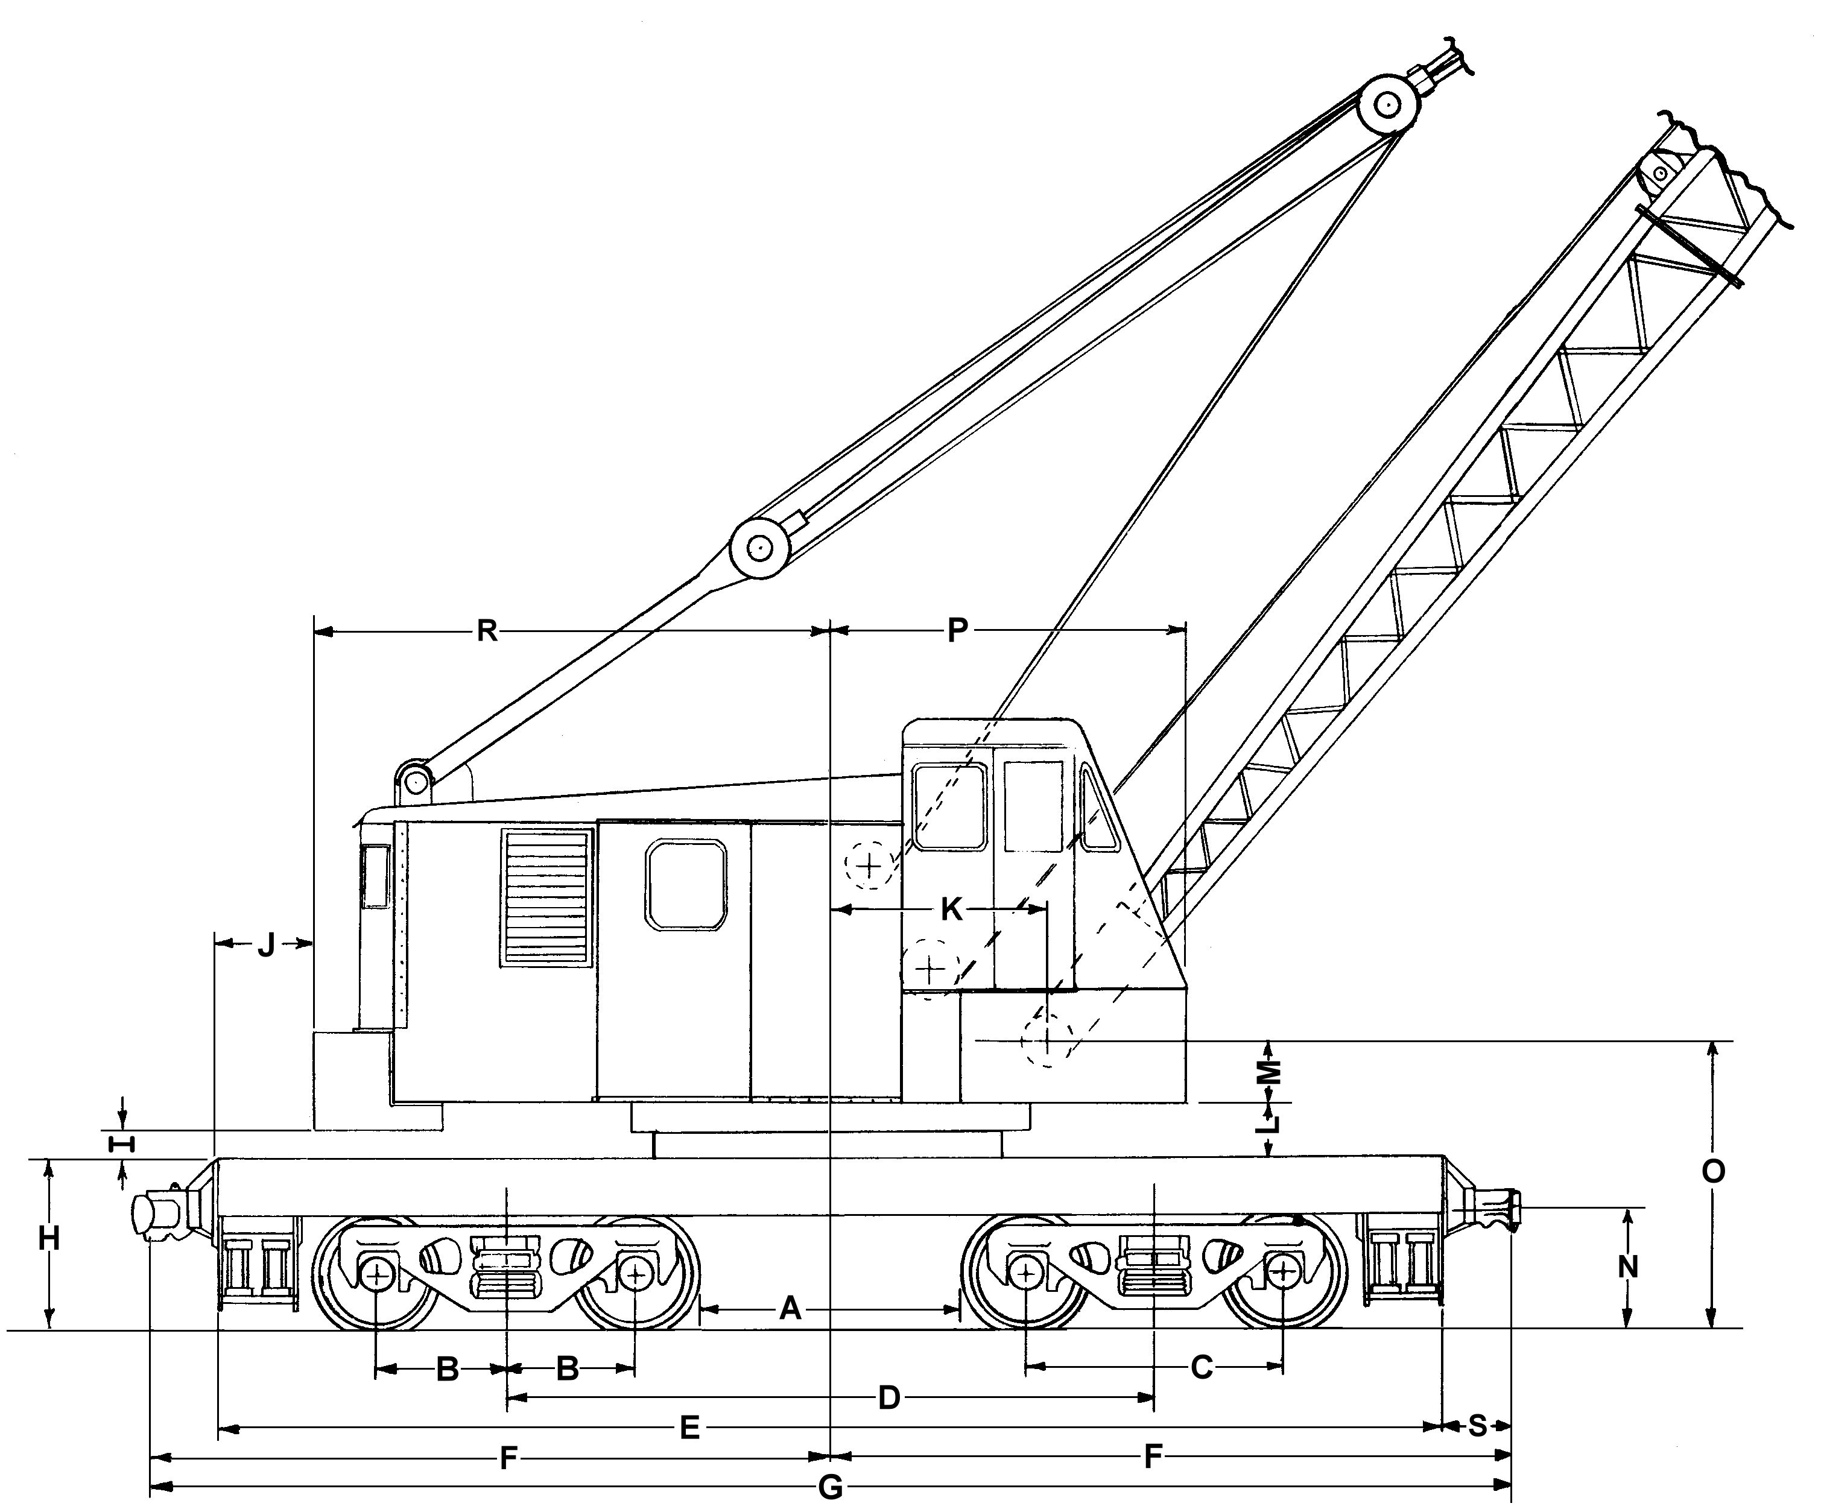

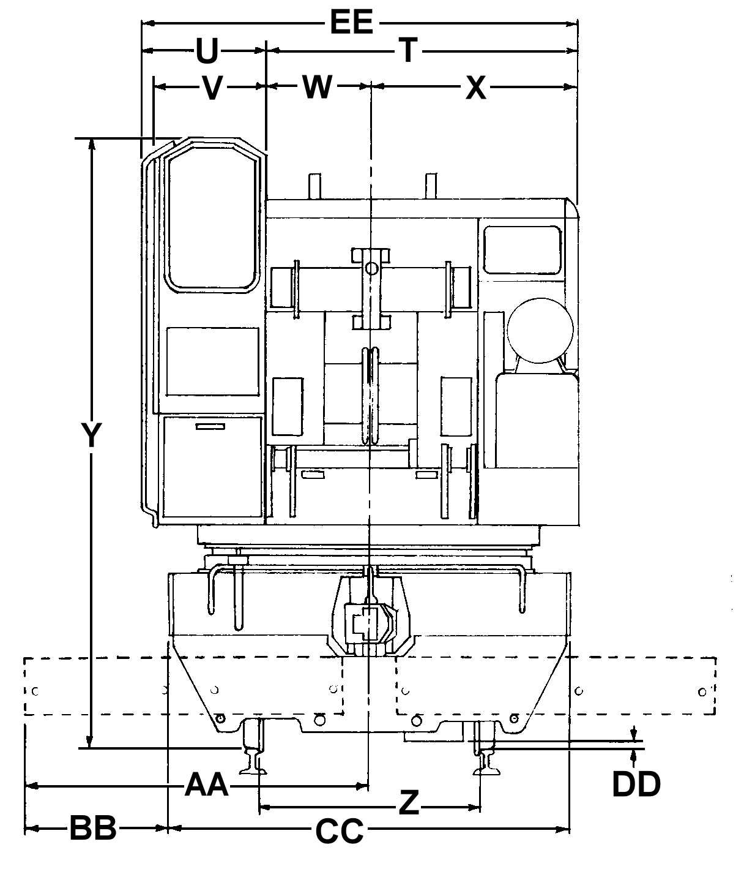

10

